My Identity and Status

Student’s Name:

Institutional Affiliation:

Course:

Tutor:

Date:

My Identity and Status

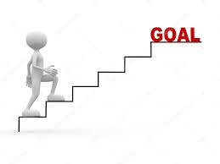

The image above represents my identity of always aiming to achieve the best. Throughout my life, I have believed that success is based on setting challenging goals and achieving them. As one continues to achieve goals, he or she sets more difficult ones and continues with the progress and process. The image shows an individual climbing up a ladder to achieve the highest goal possible. The image shows that to achieve the highest goal possible, one must begin with the first step. As I continue making steps, I may get tired in the process. However, it is through my will and determination that I will continue climbing up the ladder. It is the spirit in me that gives me the urge to continue. The image shows that the highest goal might seem a bit far when one is still down the stairs. However, it is achievable, and this is what is most important to me.

My desire to achieve the best impacts my daily life in different ways. It enables me to set goals from time to time. Setting goals has enabled me to develop effective plans for achieving them. For example, if I set the goal of getting a good grade at the end of the year, I make plans on how I will read all the required materials and prepare effectively for the examinations. My identity has enabled to thrive in challenging situations. In my life, I have seen many situations in which individuals have panicked due to the fear of trying out new things. For my case, I am always interested in trying out everything that comes my way. Apart from this, my identity has enabled me to work hard in everything that I do. If I do not work hard, I will not achieve the best. Therefore, with my identity, my focus is on achieving the best in all aspects of life.

